Aws intro 2

Aws global infrastructure 2

AWS VPC 3

VPC Components 3

Route Table 4

IP Addressing 5

Vpc types and Vpc security Group 7

Security Group – defence at instance Level 7

Network ACLs – defence at subnet level 9

Nat Instance 15

NAT Gateway 16

VPC wizard 16

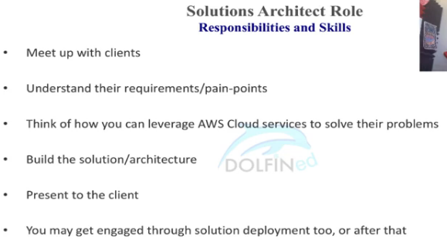

* Aws is provides services as building blocks and we need to put them together to provide solutions

# Aws intro

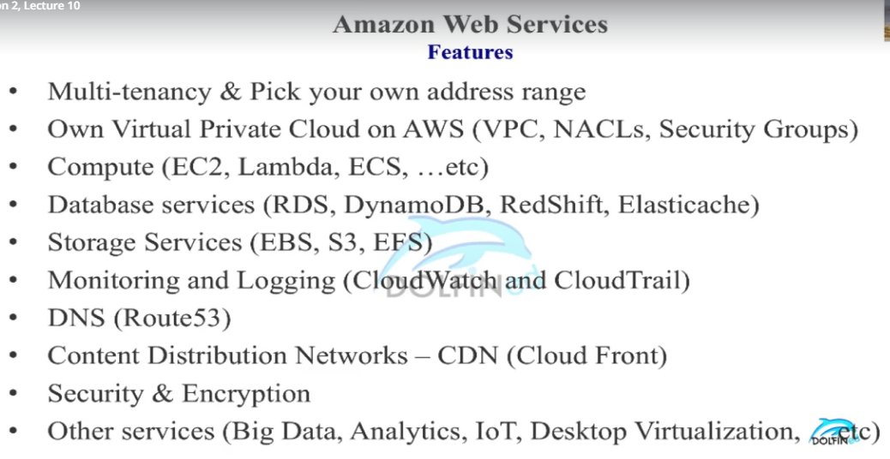

Aws access methods

* Console
* RestApi
* SDKs
* CLI (command line interface)

# Aws global infrastructure

<https://aws.amazon.com/about-aws/global-infrastructure/>

one AZ -> one or more discrete data-centers

one region -> one or more AZs.

Edge locations – content delivery network to reduce the latency across world.

# AWS VPC

* Virtual environment or datacenter for one client, client can have multiple vpcs (ex. Department)
* Similar to like own datacenter inside AWS
* Logically Isolated from other vpcs on aws
* Scope - vpc is region specific, ie. Cant span multiple regions
* vpc can span multiple AZs
* vpc subnet is AZ specific cant span multiple AZs.
* Single AZs can have multiple vpc subnets

## VPC Components

* Implied Router – logical router to route the request to vpc subnets
* Route Tables – to define rules for incoming and outgoing requests
* Internet Gateway – to communicate outside world ie. Internet and other aws services
* Security Group – Last defence act as NIC (network interface card)
* Network access control list – First Defence inside vpc
* Virtual Private Gateway – to connect private client networks or companies

Each VPC subnet must associate with single route table.

But one route table can associate with multiple subnets.

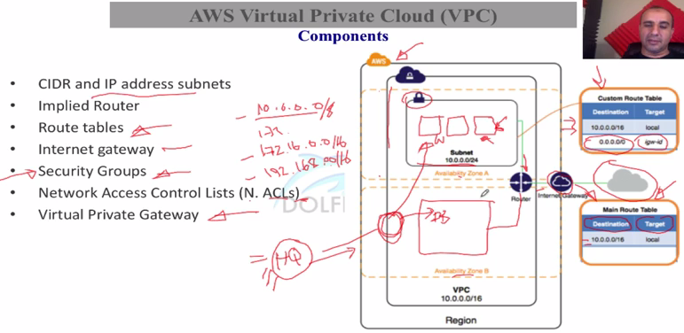

### Route Table

Router will do two functions implicitly

1. Routing table
2. NACL function

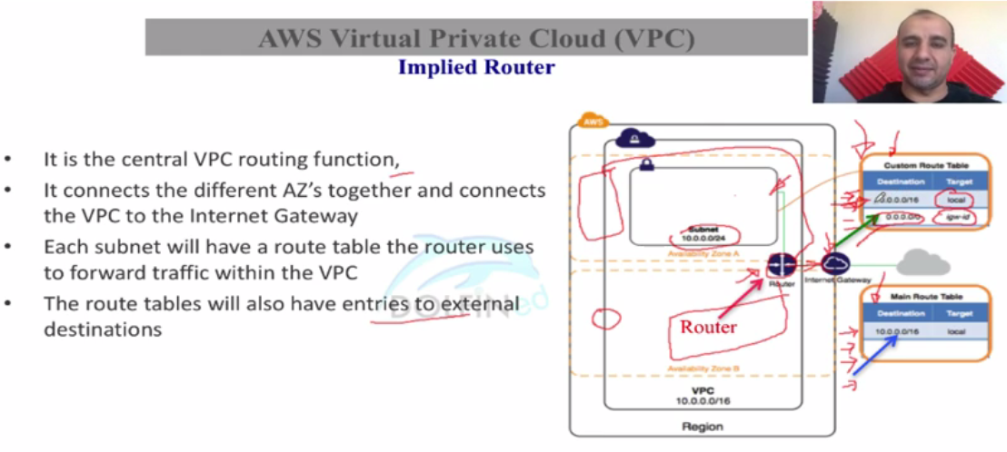

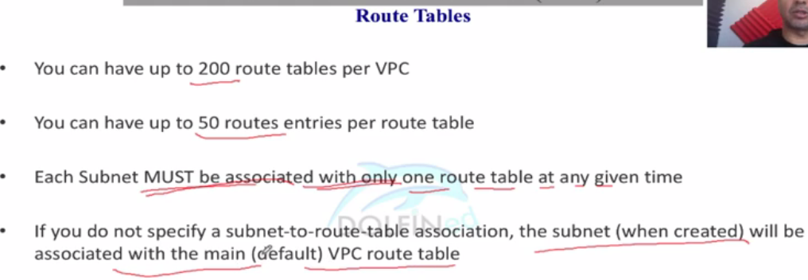

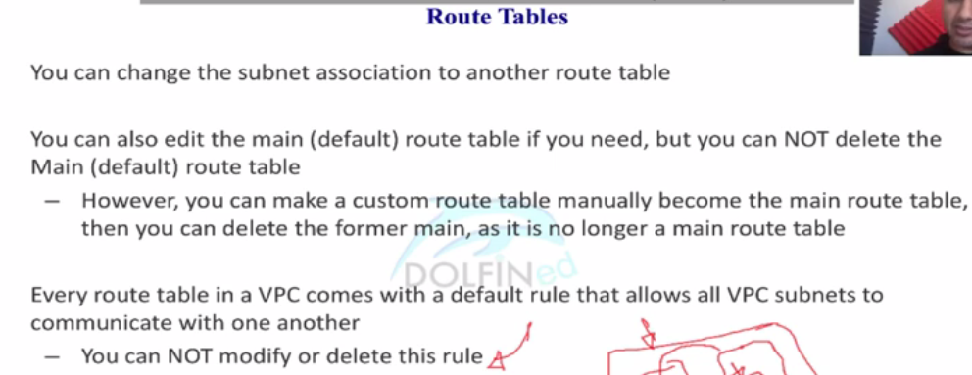

Route table has one entry which is cidr of vpc that can not be deleted and come by default.

And def RT comes while creating vpc has entry which directs traffic to igw also(0.0.0.0/0 -igw)

Cust RT don’t have entry which directs traffic to igw

Route table to subnet relationship (one to many)

### IP Addressing

Min size of CIDR block is /28 and Max is /16

Reserved ips in each subnet – First Four and Last one (Total 5)

Ex. For Subnet CIDR 10.0.0.0/24

10.0.0.0 is base network

10.0.0.1 Vpc router

10.0.0.2 DNS related

10.0.0.3

future use

10.0.0.255 last one for future use

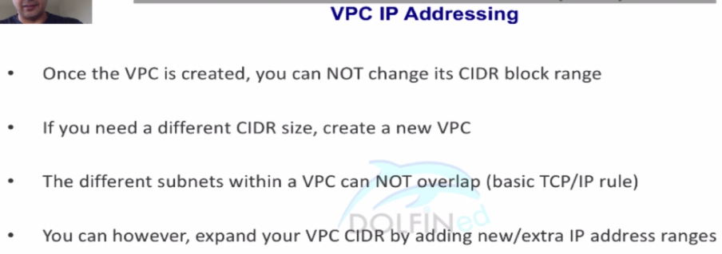

Some of the private Ip address range

10.0.0.0

172.16.0.0

192.168.0.0

When you expand vpc with extra cidr block, it will be added to main route table automatically, means cant be deleted its entries from main route table

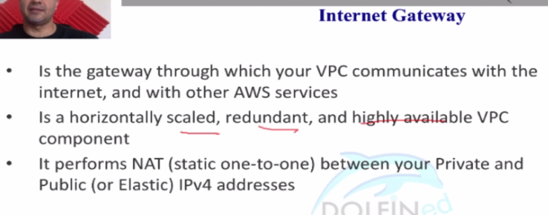

One IGW per VPC. IGW cant be connected to mult VPC at a time

You cant attach an igw with vpc if vpc already attached to another igw. You have to detach it and then can attach with new igw

## Vpc types and Vpc security Group

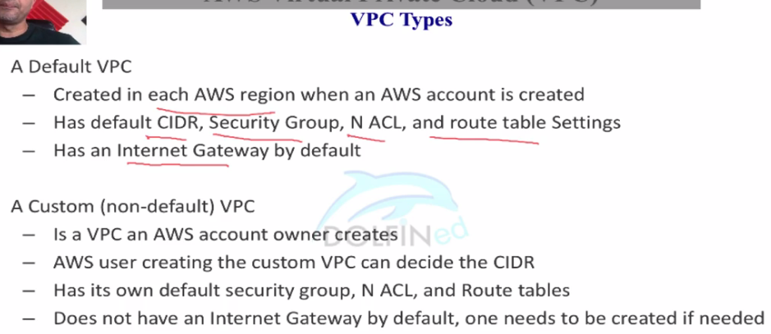

<https://docs.aws.amazon.com/vpc/latest/userguide/VPC_Security.html>

### Security Group – defence at instance Level

* Virtual Firewall
* Directional – allow rules only

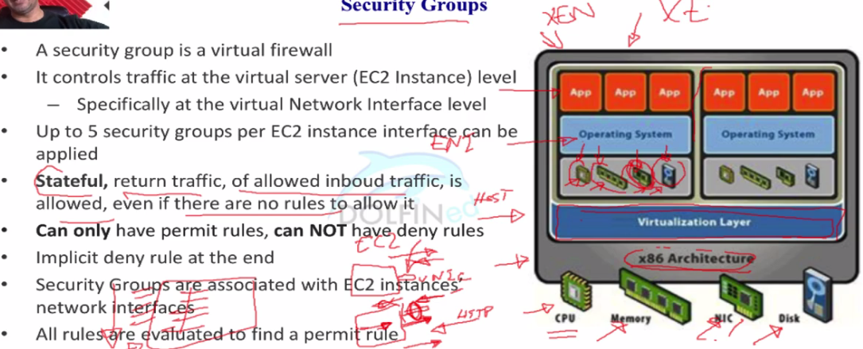

* Default sg of custom or default vpc has inbound rules which accepts traffic from the instance associated with same sg.
* Custom sg of any vpc has default no inbound rules means inbound traffic prohibited
* Outbound rules allows all traffic to go from sg for all custom or default sg. You can delete this default rule.

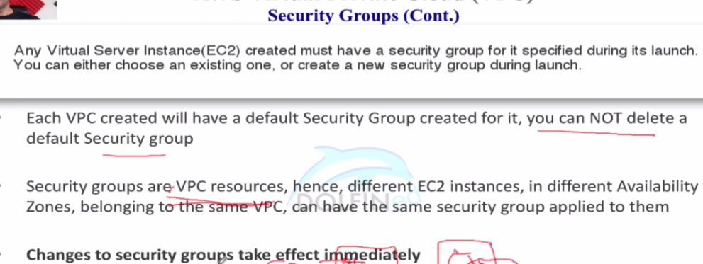

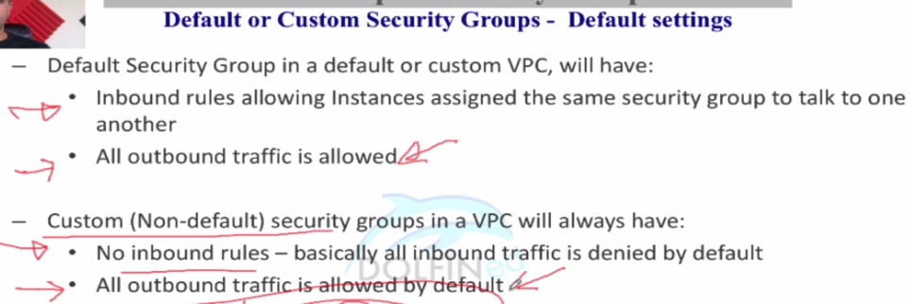

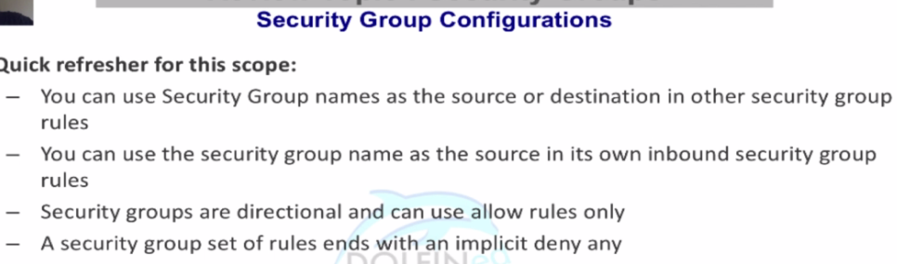

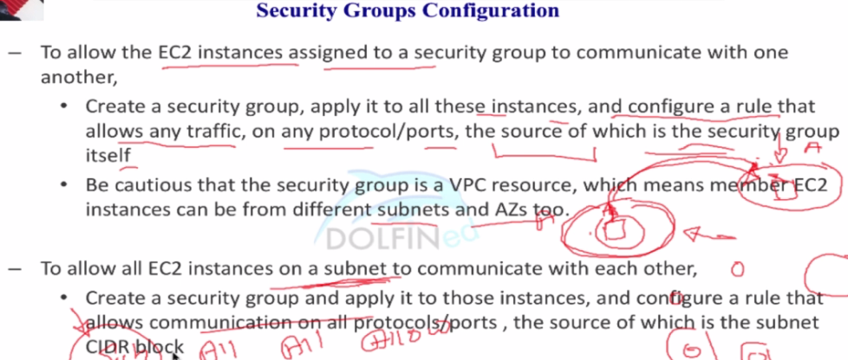

Read faqs of sg

### Network ACLs – defence at subnet level

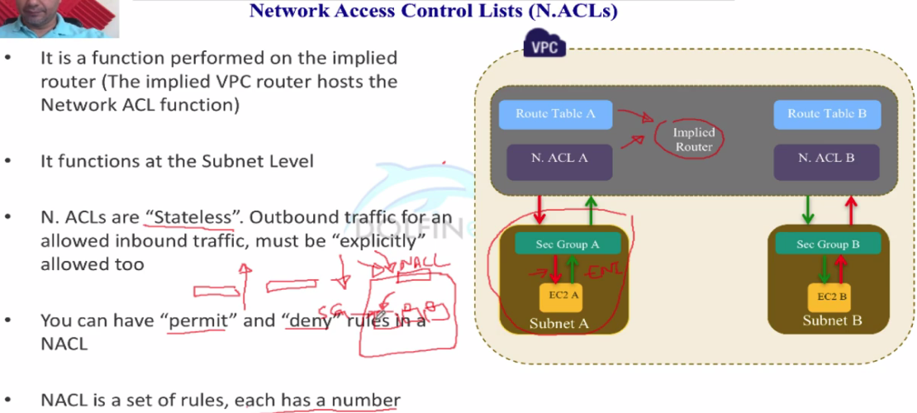

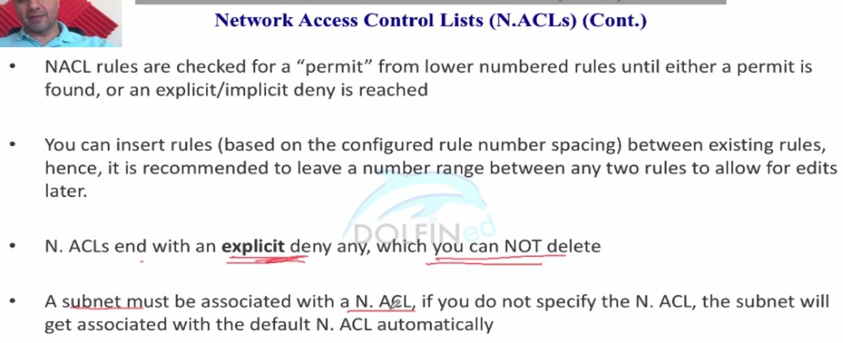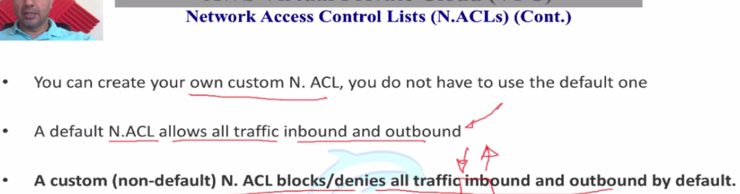

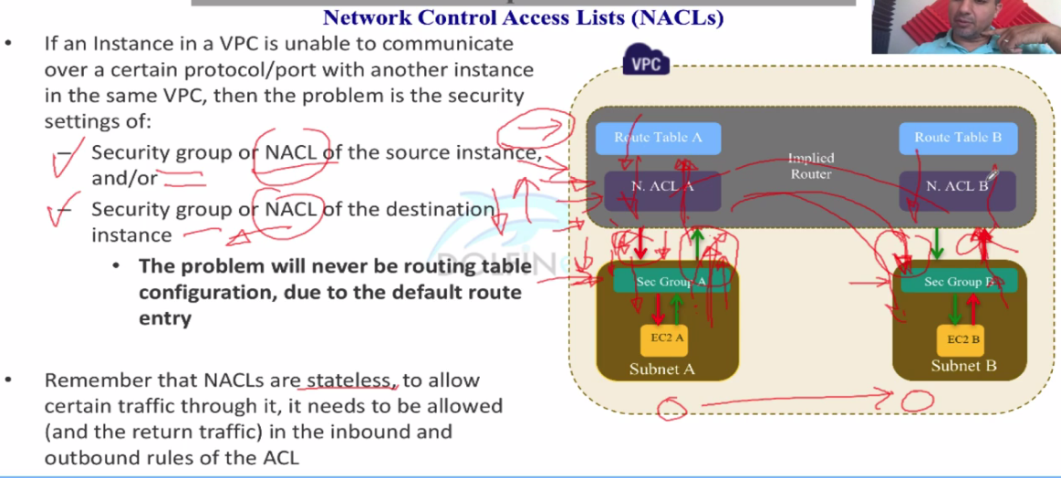

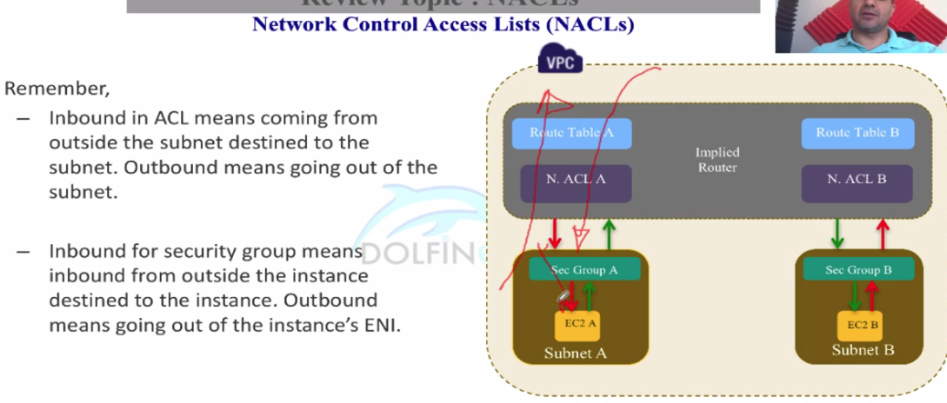

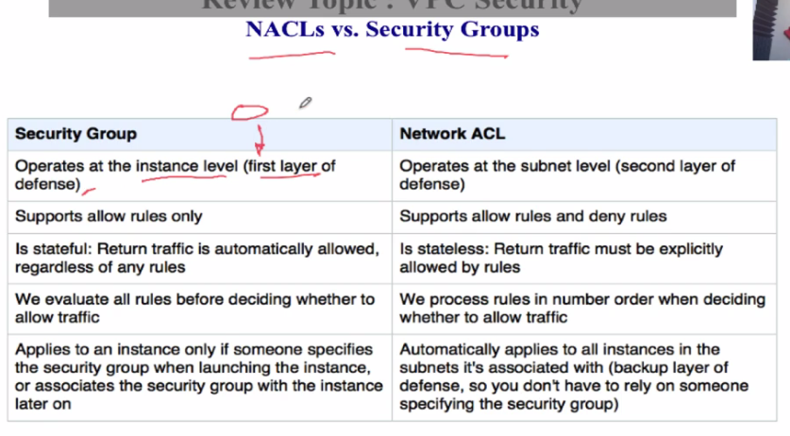

* For def nacl (for def and cust vpc) – there is inbound and outbound traffic is allowed by default(0.0.0.0/0, allow in outbound and inbound entry)
* For cust nacl (for def and cust vpc) – there is explicit deny for inbound and outbound traffic.

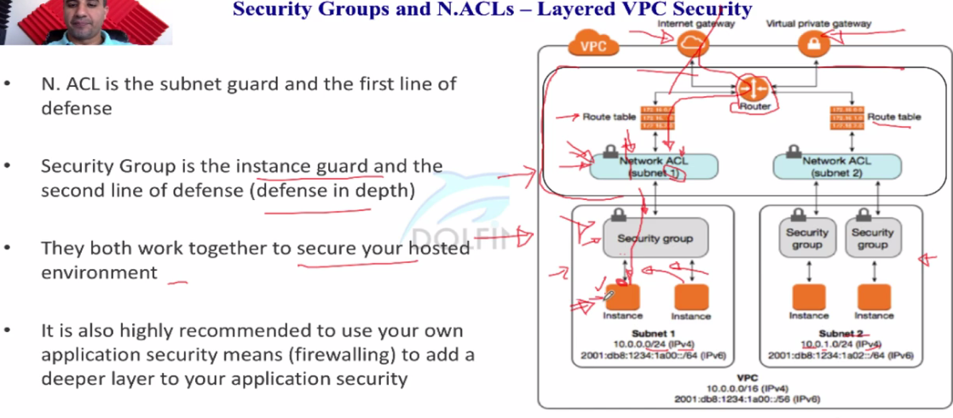

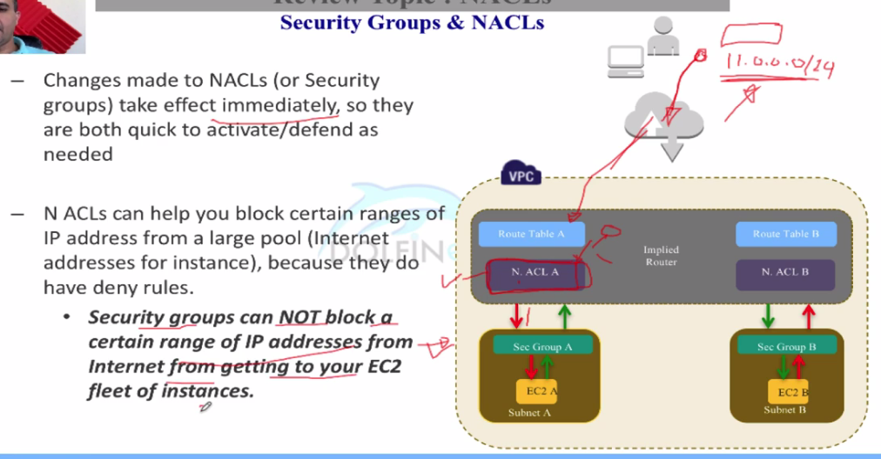

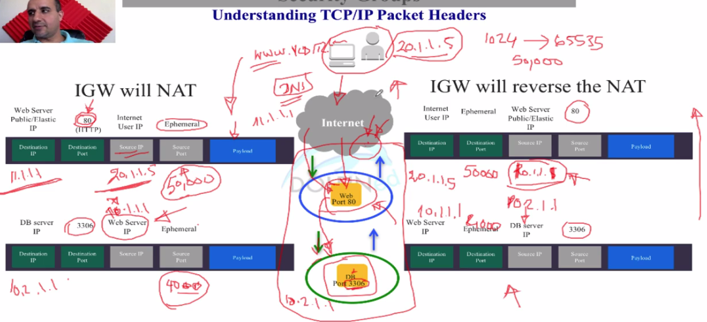

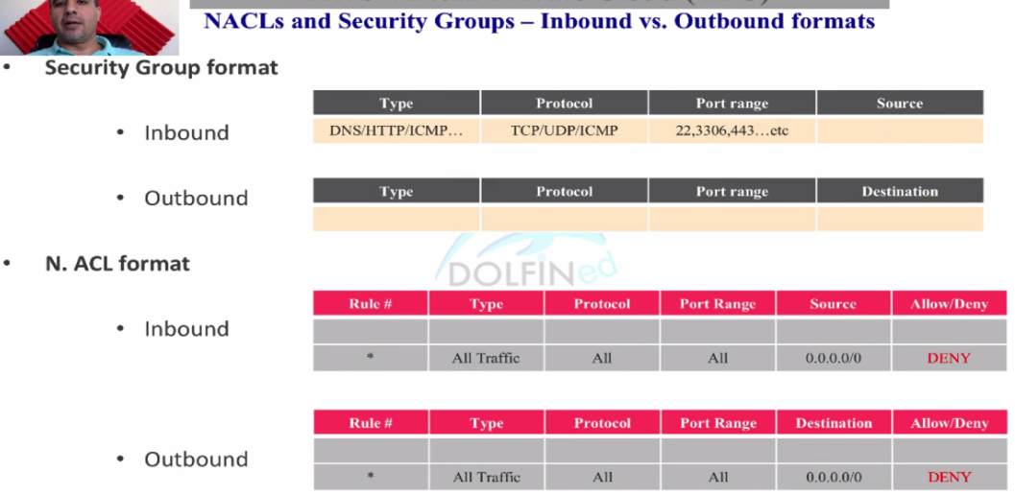

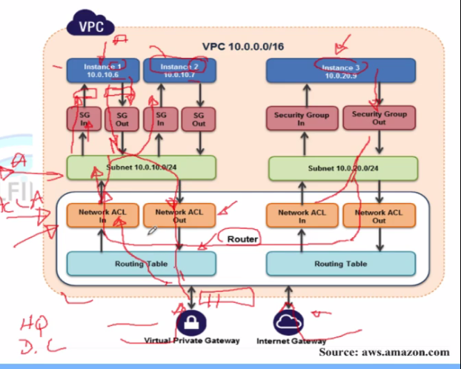

In above image..

* If traffic comes from internet gateway then routing table, nacl and sg will be involved for the security
* If inst. 3 wants to communicate with inst. 1 then nacl and sg wll be involved and rountng table will not be involved
* If inst 1 want to communicate with inst 2 then only security group will be involved

### Nat Instance

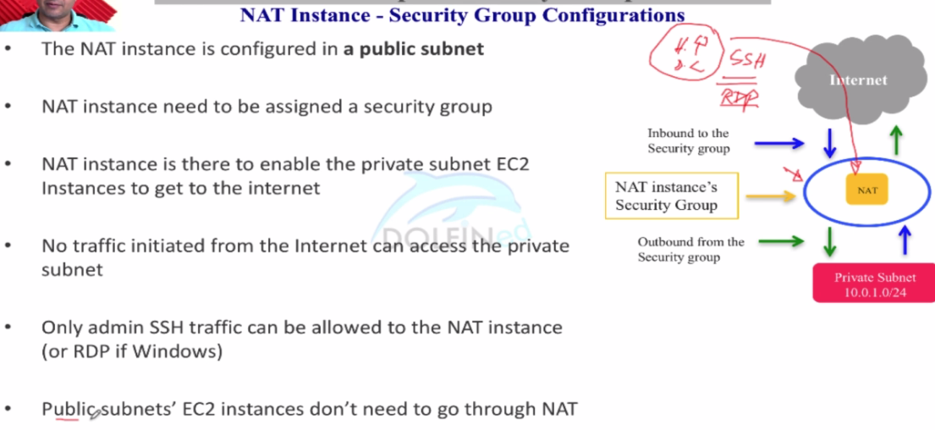

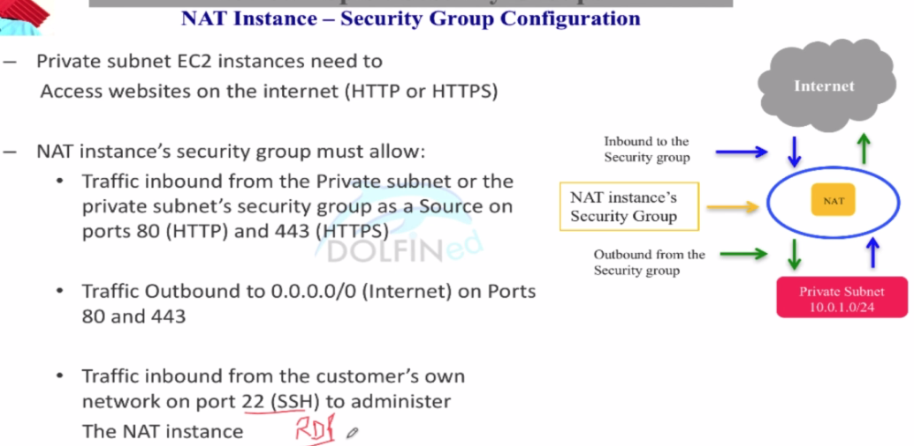 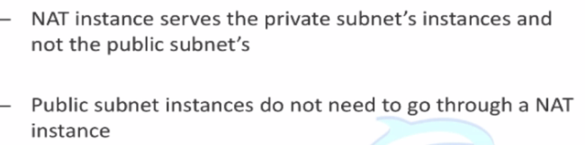

For NAT instance, source – destination check must be **disabled**.

### NAT Gateway

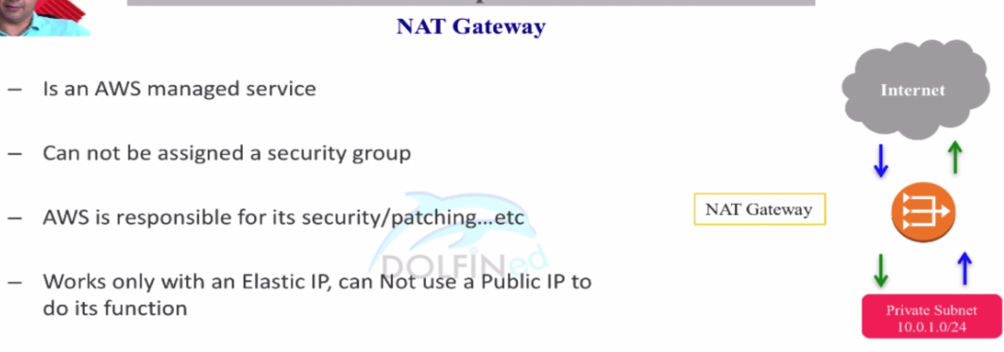

It is also used as a proxy for private subnet’s instances for security updates as like NAT instance.

Nat inst can be used be public ip and elastic ip as well but NAT G not.

Nat inst need to be assigned sec group but NAT G not.

### VPC wizard

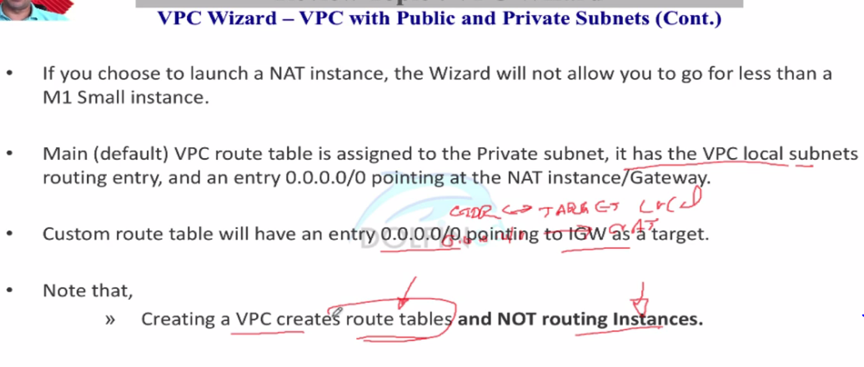

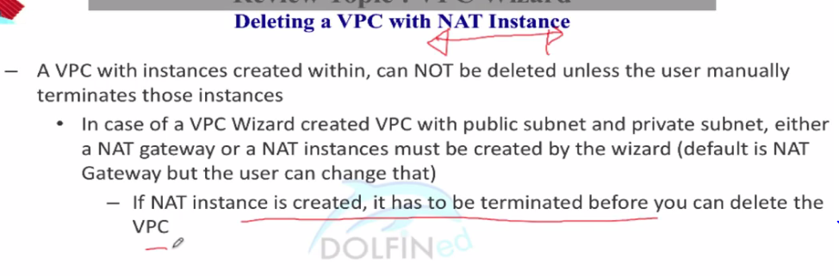

You can get upto 5 elastic ips per account

## Vpc peering

* To connect vpcs each other
* You can peer two different vpcs of the same account, can connect a vpc of one corporate to a vpc of other corporate
* Vpc peering can be done with the same region weather it belongs to same account or different account but from Nov17, inter region vpc can be connected to each other and traffic pass through aws backbone and does not pass over internet
* Vpc peering is one to one, a-b b-c that doesn’t mean a-c is peered
* Internally one or more subnets of both vpcs connect together, like test vpc, dev vpc and production vpc connect each other
* Can’t create multiple peering connection between two vpcs.

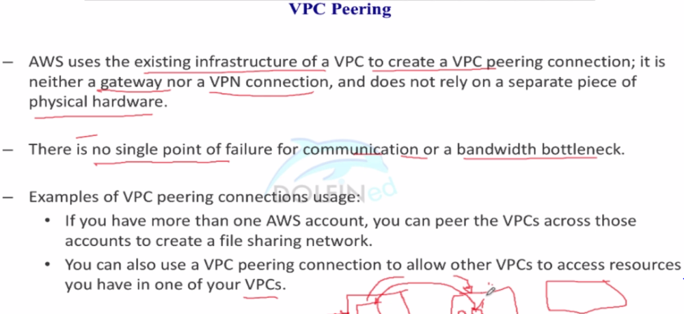

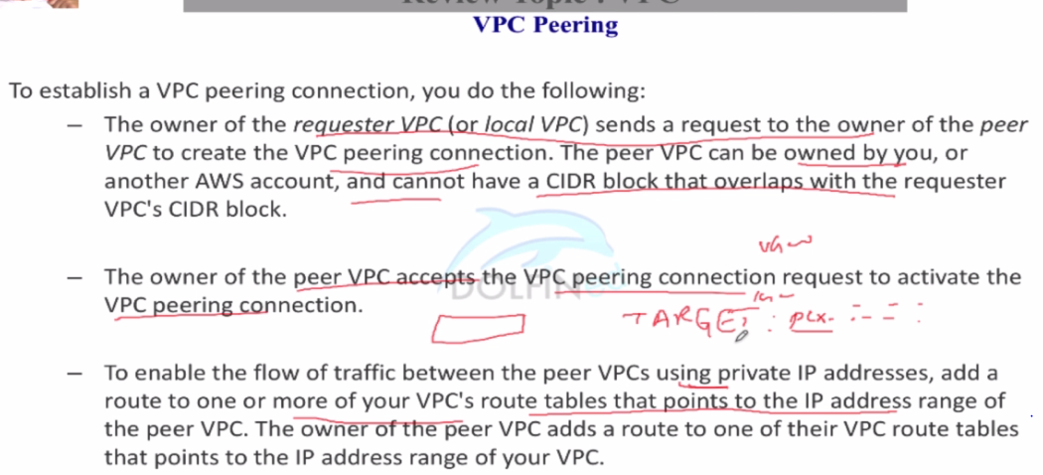

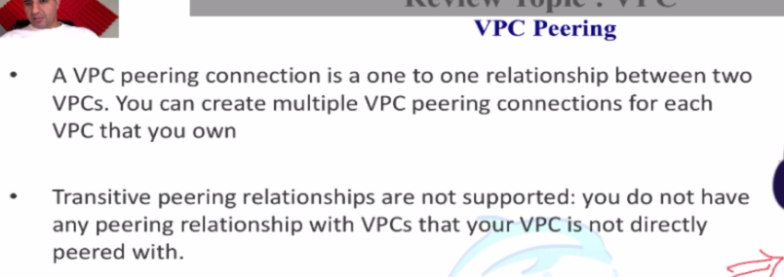

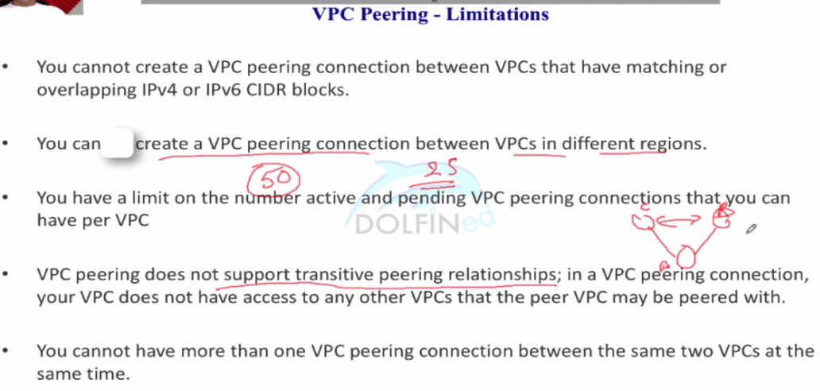

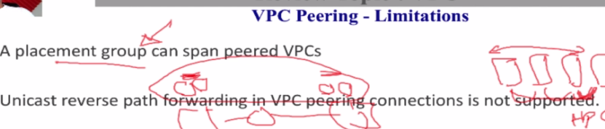

While peering a connection to another vpc, you need to create a pipeline to communicate by adding respective entries in the route table. More details provided on below link

<https://docs.aws.amazon.com/vpc/latest/peering/vpc-peering-basics.html>

### VPN – virtual Private Network

* Vpn connection are established through internet, no private tunnel to communicate

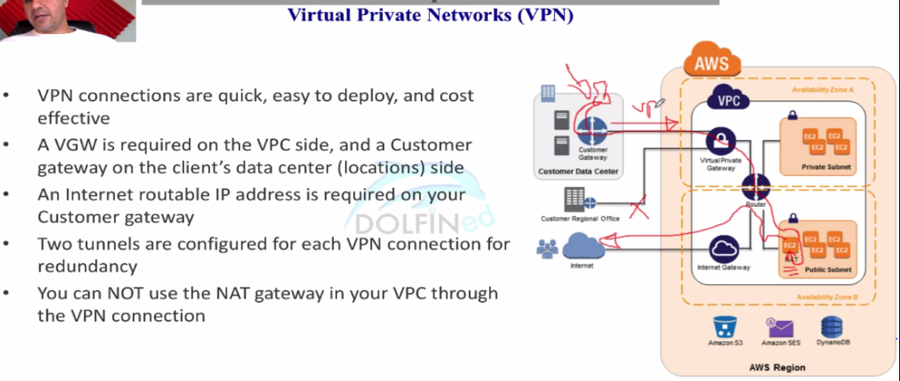

Vpg can handle multiple connections with customer gateway and it is one only from aws side. But it is not single point of failure. It is high tolerant and redundant

Soft limit for mult.conn to cust. Gateway is 10. You can request more to aws

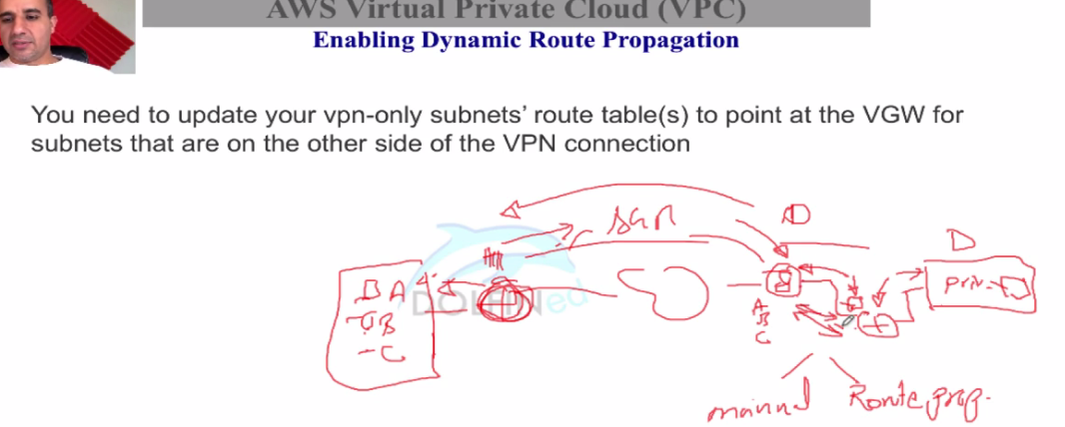

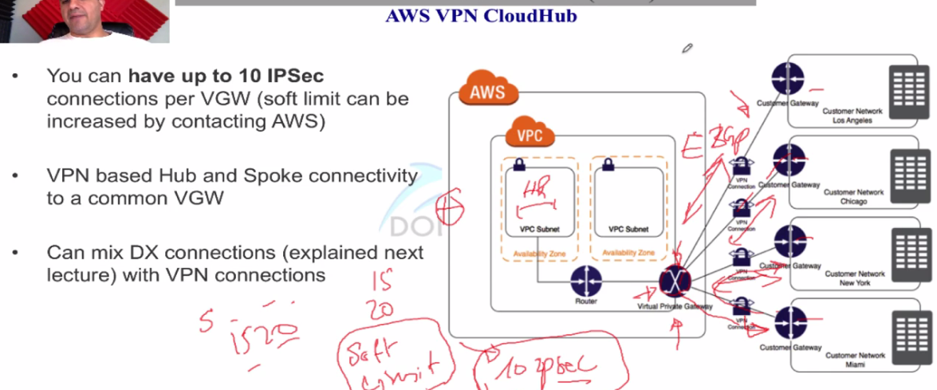

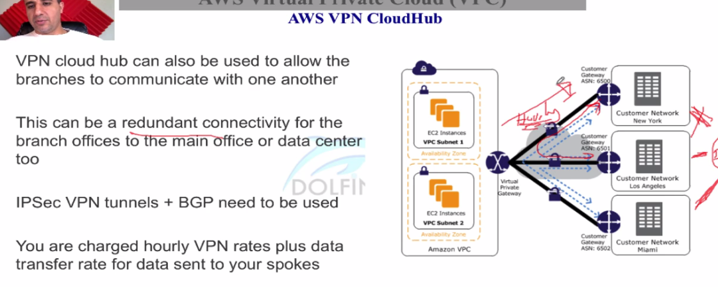

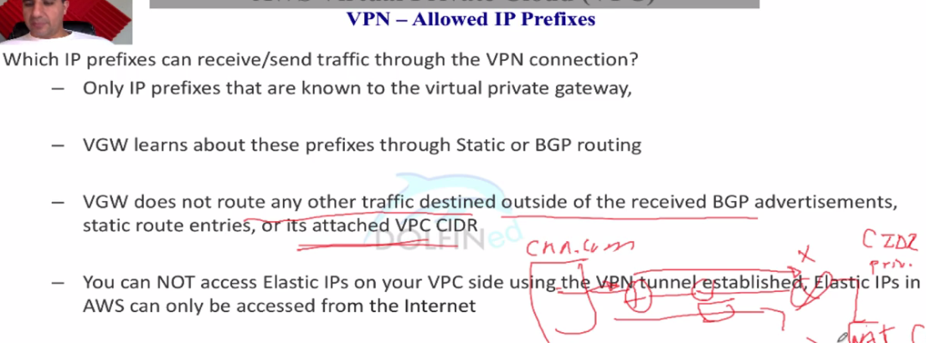

### Vpc – direct connect

